Proiect CHS – MIST

Diagram UML:

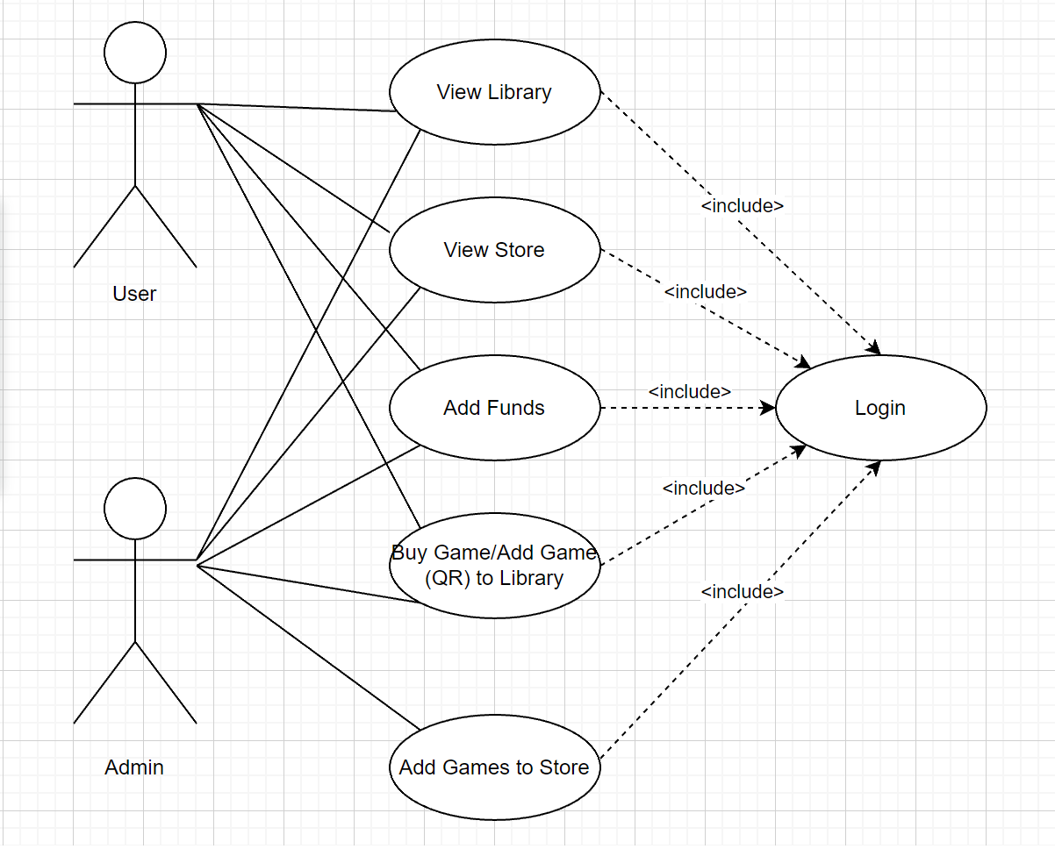

Ecranele Aplicatiei:

* Welcome Page
* Register Page
* Login Page
* Profile Page – in progress
* Store Page – in progress
* Library Page – in progress
* Scanning Pages – in progress

Technologii folosite:

* Android Studio – Java
* Firebase